UML

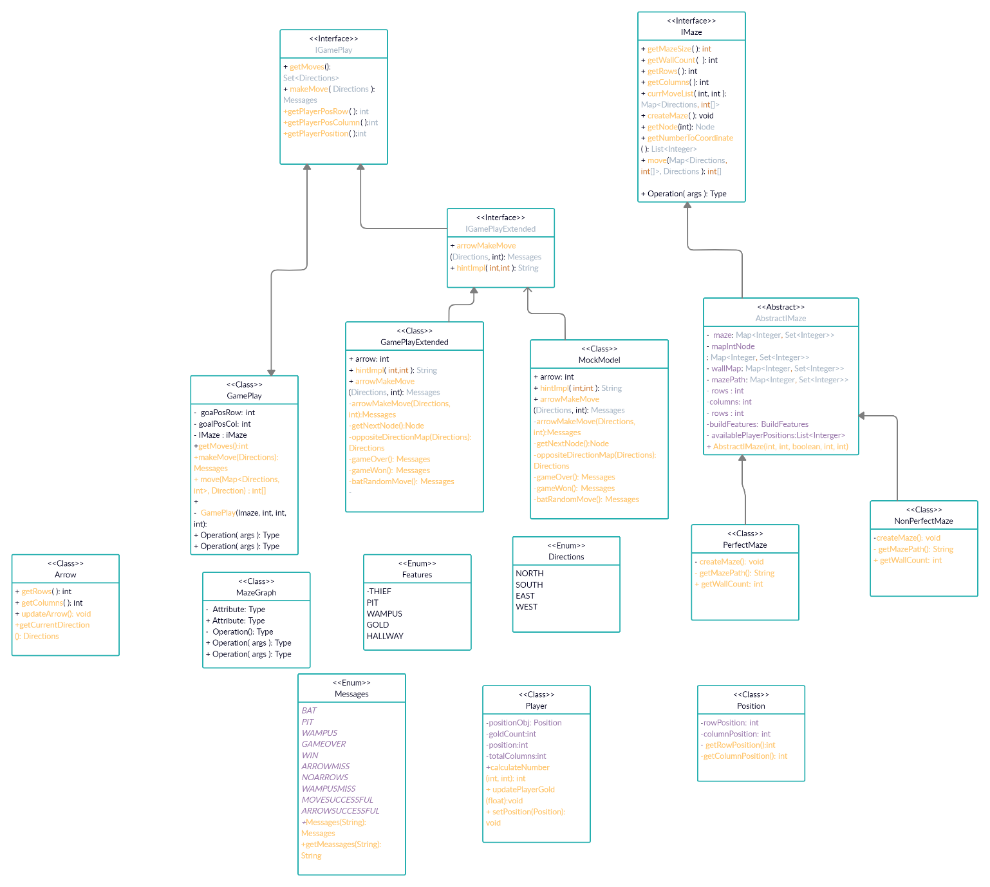

View UML

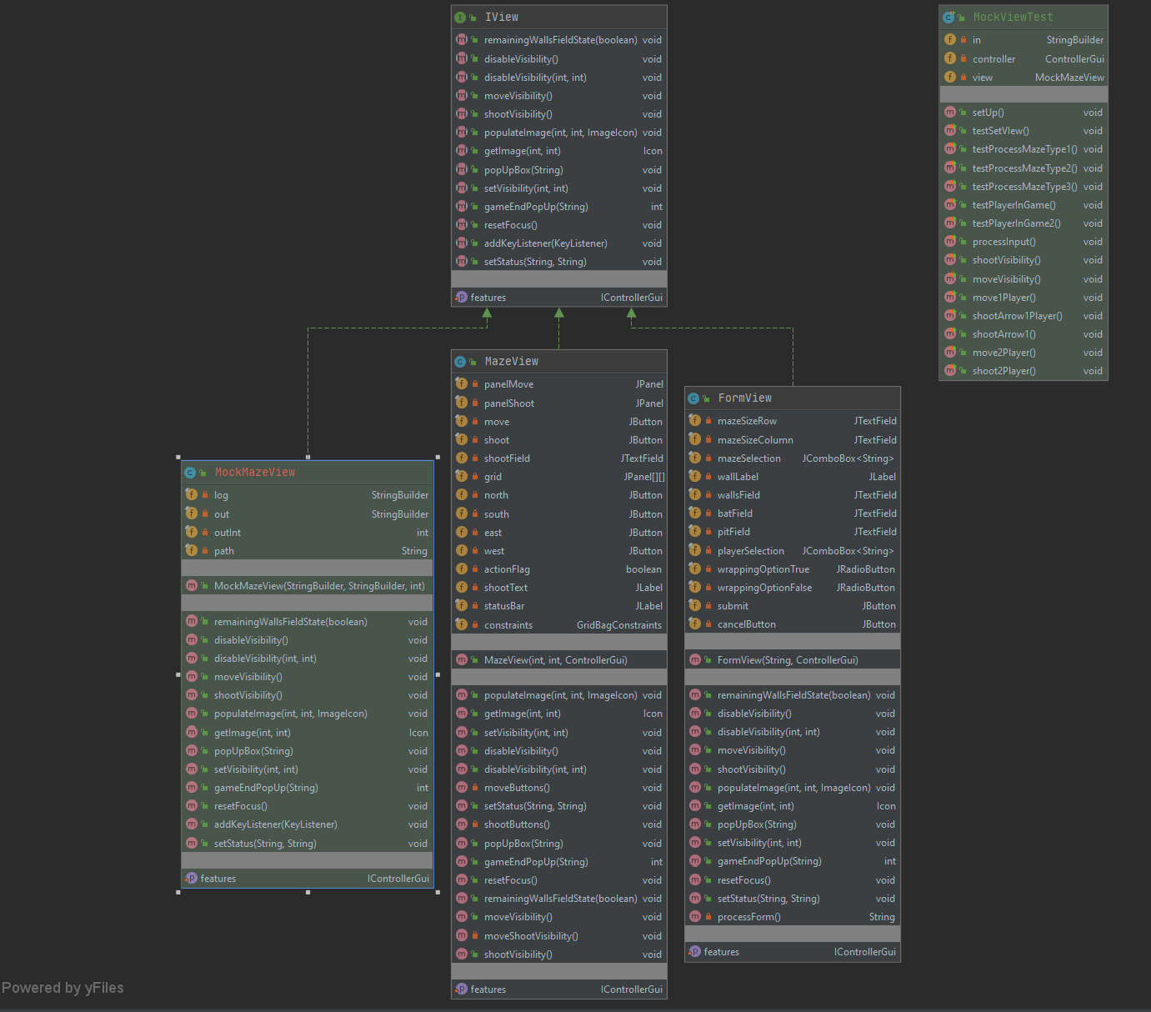

Controller UML

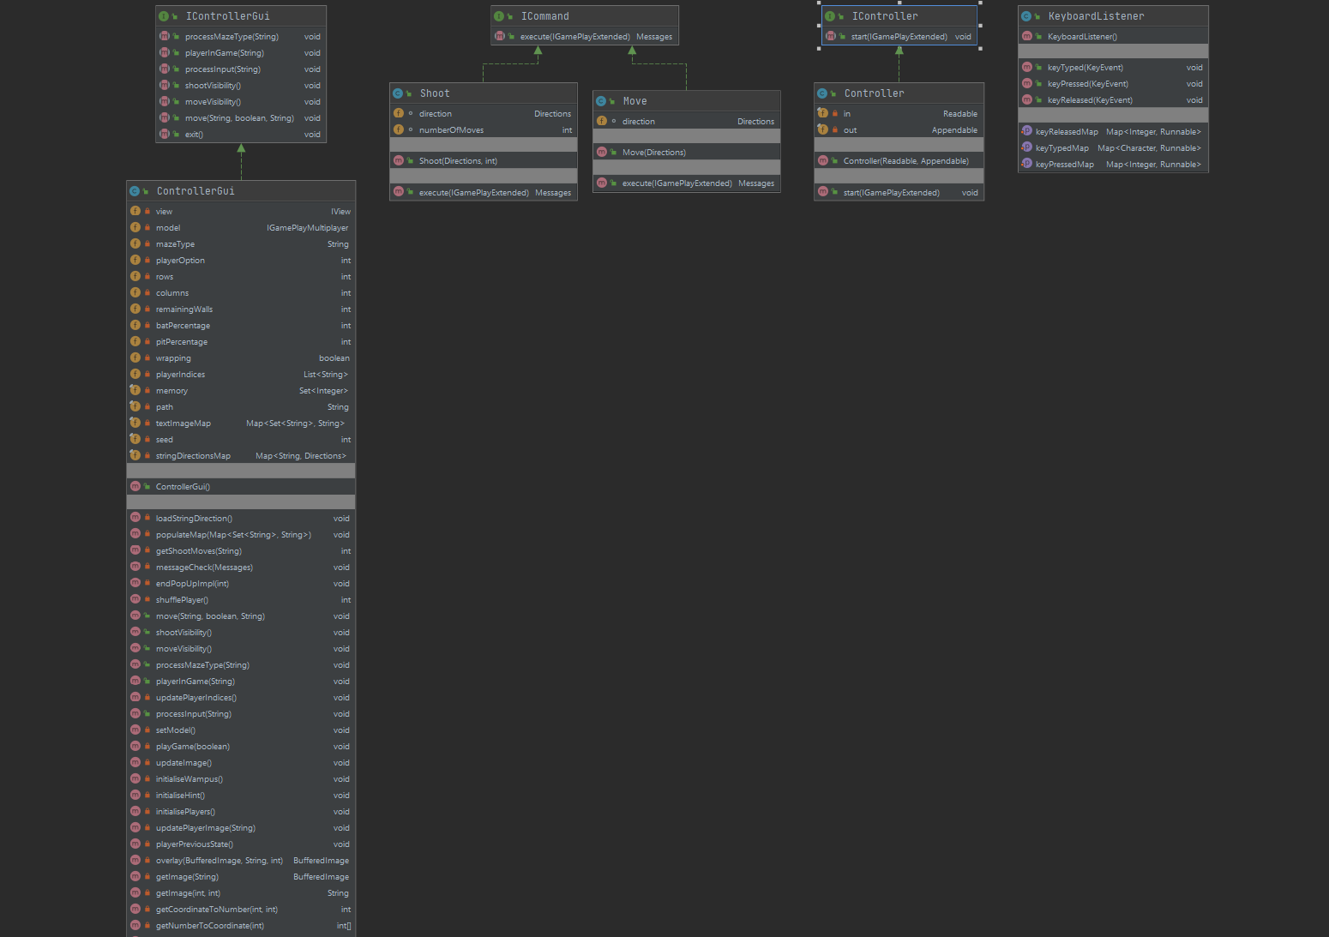

View UML

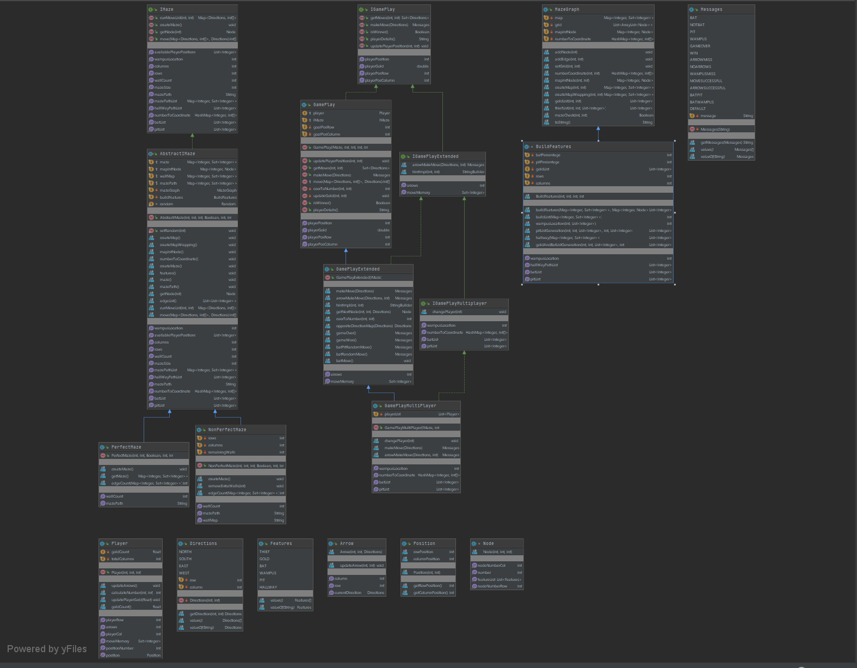

Test Plan

The test plan has all the checks at a high level and would be improved during course of development of the homework. Certain assumptions have been made while designing the problem. Bats remain at the same location after picking up a person. The bats and pits percentage in the maze are considered after removing the hallways from the maze. The player starts at a position where none of them exist. The arrows a player carries is fixed to a constant value of 3 and cannot be changed. The view has been thoroughly tested for by using a mock view to test for all the cases during the view. Each of the variables in the classes are tested for validity as well as for the exceptions that will be thrown for invalid entries. All the getter methods in each of the concrete classes and abstract class are tested. Each of the getter method is checked for its validity. Following are few of the test cases that will be tested.

